CAS PY 106

In-class Note 4

1. Ball on a string
2. Small ball with force 10N is hung from string made of insulating material
3. Ball and string is in region of space in which there is a uniform electric field with E = 2.0 \* 10^4 N/C directed horizontally to left
4. Ball has unknown net charge and has F = 10N downward and want to know the net charge of the ball
5. When ball is in equilibrium, string is at 45 degrees angle
6. 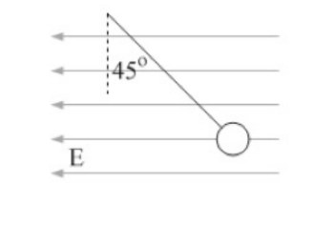
7. We know charge is negative because it is going against the electric field
8. Free body diagram: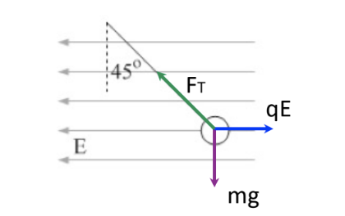

F = ma = 0

q \* E \* sin(45 degree) = m \* g \* cos(45 degree)

Since cos(45)=sin(45),

qE = mg

q = mg/E

q = 10N/(2.0\*10^4 N/C)

q = 5 \* 10^-4 C

1. Ball on string Part 2
2. If the angle was changed to theta, the solution becomes

F \* sin(theta) = q \* E

F \* cos(theta) = m \* g

Dividing two equaitons, we get

tan(theta) = q \* E / (m \* g)

q = m \* g \* tan(theta) / E

1. Energy instead of forces
2. Recalling the conservation of energy by Gravitational energy 🡺 kinetic energy, mgh = 1/2mv^2 where v = (2gh)^.5 for ball at height h falling to the ground
3. Potential Energy difference (uniform fields)
4. U(final) – U (initial) = -mgh when ball is falling from sky to ground with height h
5. Delta U = -mgh
6. Similarly, for a charge q moving distance d parallel to electric field, change in electric potential energy is Delta U = U (final) – U (initial) = 0 – U(initial) = -qEd where d is the distance
7. Work we need to apply is W = - delta U = qEd (unit is Joules or J)
8. The change in potential energy is positive if the object is moved opposite to the force applied by the field and negative if it is moved in the same direction as the force applied by the field
9. 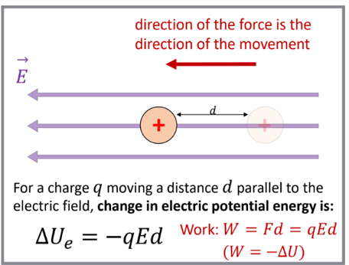
10. Electric potential (voltage) around positive/negative charge
11. 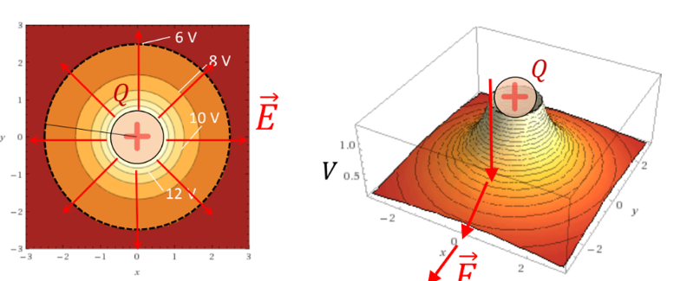
12. Electrical potential difference, also known as voltage, is external work needed to bring a charge from one location to another location in electric field
13. Voltage V = kQ/r with unit Joules/C or J/C where Q is the point charge
14. Delta U = q \* delta V where q is not the point charge
15. \*\*Electric field always points in the direction of decreasing electric potential\*\*
16. Since electric potential decreases as you get further away from the positive point charge, electric field is directed away from the point charge
17. 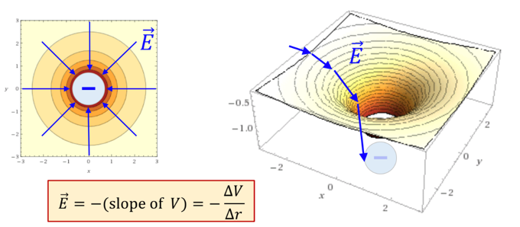
18. Since electric potential increases as you get closer to the negative point charge, electric field is directed into the point charge
19. E = -delta V/ delta r
20. Equipotential in uniform E field
21. Field lines are perpendicular to equipotential
22. Uniform electric field 🡪> equipotentials are parallel and equally spaced
23. 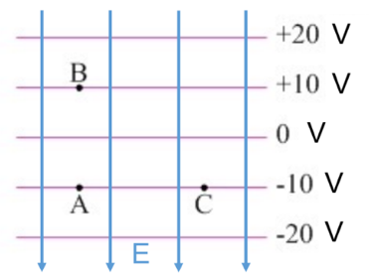
24. In the figure above, electric field is directed downwards because electric potential (V) decreases as it goes down
25. If equipotentials are 10 cm apart in the figure above, the magnitude of electric field is:

E = -delta V/ delta r

E = -(10-20)V/-0.1m

E = 100V/m

1. Potential difference, delta V
2. Potential difference, delta V, in a uniform field
3. Delta v = delta U/q = -F\*delta r \* cos(theta) /q = -q\*E\*delta r\*cos(theta)/q = -E\*delta r\*cos(theta) where theta is angle between field and displacement
4. When we only need the magnitude of potential difference, delta V = Ed where d is distance moved parallel to the field
5. Equipotentials in a uniform field
6. Delta U = q \* delta V
7. 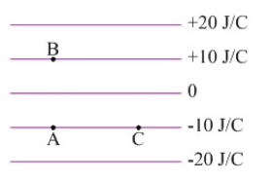
8. How much work do you do in moving +5nC charge from point A to C

W = -Delta U

W = -q \* delta V

W = -q\*0

W = 0

Work done is zero

1. How much work do you do in moving 5nC charge from A to B

W = -Delta U

W = -q \* delta V

W = -q \* (30 – 10)

W = -5 \* (20)

W = -100 nJ

Since I am doing the work, we need to put 100nJ amount of work